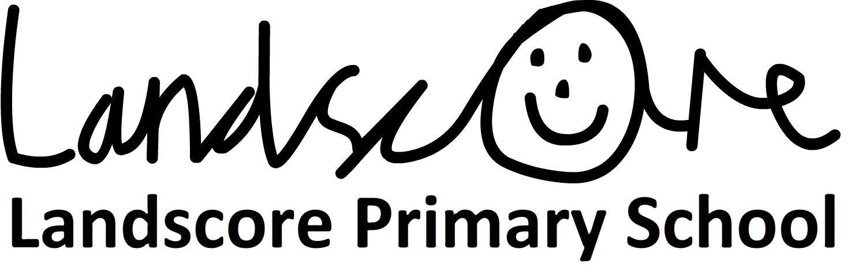
Information Letter for Parents –Autumn Term 2019 – Year 3 and 4

Dear Parents and Carers,
We would like to take this opportunity to say welcome back after half term! We had a fantastic first half term in Team 2 and we are really excited to be back.
Our topic this term is “Roman Britain” - Please find some time to read through this term’s curriculum map as it will provide you with information about what children will be learning over the coming weeks.

The Multiplication Tables Check
As some of you may be aware, the Department for Education (DFE) have confirmed that all schools will be expected to administer a multiplication test to their year 4 pupils from 2019-20.
We are continuing to use “TimesTable Rockstar” to support the children’s times tables knowledge and if possible would encourage children to use this programme to practise their times tables at home during the week. This website is a great resource for helping the children get used to answering their times table questions on a computer and within a set time limit, which is similar to the design of the DFE’s Multiplication Check test.
If you would like to see more information about this you can either speak to your class teacher, or visit https://www.gov.uk/guidance/multiplication-tables-check-development-process#introduction
We will also be continuing with our weekly times table test, to check the children’s fluency with their timestables.
Cinema Trip - Rotten Romans
This term we will be taking a trip to Okehampton cinema to watch “Horrible Histories: The Movie – Rotten Romans”. This trip will be on Wednesday 13th November and
If anyone would like to volunteer, please indicate this on the reply slip when the letters are sent home. We will try our best to accommodate as many volunteers as possible.
QE Gymnastics Festival
On Tuesday 3rd and Wednesday 4th of December each class has been invited to take part in a Gymnastics Festival, run by the Sports Department at QE. Each class will be attending their own session and will need to bring their PE kit to school on the day of their session. The children will walk to QE upper school to take part in the event, which is organised by QE. There will be a letter sent out nearer the time to confirm the dates and we would ask anyone who may be able to volunteer to help escort the children to the event to indicate this on the form - it would be greatly appreciated!
Open Afternoon - Roman Day
Our Open Afternoon this term will be on Friday 13th December between 2pm - 3:30pm. We will be dressing up as Romans for the day and creating mosaic tiles in the afternoon. We hope as many of you as possible can join us so we can share with you and celebrate what the children have learnt so far this term.

Dates for your diary
- Cinema Trip - Rotten Romans - Wednesday 13th November
- Gymnastics Festival - Tuesday 3rd December and Wednesday 4th December
- Open Afternoon - Friday 13th December 2pm - 3:30pm.
If you have any concerns or questions, please do not hesitate to come and talk to your child’s teacher. We are usually available at the end of the day for a quick chat outside the main doors, or alternatively we can arrange a mutually convenient time for any longer discussions.
With kind regards,
Miss Maddison, Mrs Houston, Mrs Williams and Mrs Turagabeci

