

**Personal, Social and Emotional Development**

**The children will be learning …**

* …to discuss and record their personal ‘Wants and Wishes’ for 2020.
* …to share and celebrate what they think they are good at.
* …to make a class charter of the things that we can do together to look after the environment.

**Physical Development**

**The children will be learning …**

* …to generate a simple list of all the ways we can look after ourselves, care for our bodies and minds and keep ourselves healthy.
* …to make good food choices and select fresh ingredients to make their own healthy wrap or sandwich.
* …to sew simple stitches on batik material using large needles and thread.
* …travel around the large apparatus in the hall and develop an awareness of safety and space.

**Communication and Language**

**The children will be learning...**

* …lo learn stories from memory and perform them.
* …express and share their opinions and ideas with others in whole class and small group discussions.
* …to understand ‘how’ and ’why’ questions and answer them.
* …to explore the meaning of and use new vocabulary such as ‘recycle’ and, ‘biodegradable’.

.

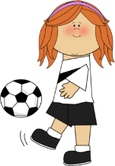

**Literacy**

**The children will be learning...**

* …to listen and respond to a range of stories which include,

‘Brown Bear, Brown Bear, what do you see?’

‘Polar Bear, Polar Bear, what do you hear?’

‘The Polar Bear’s Home’

‘George Saves the World by lunch time’

* …to contribute to our class charter
* …to write simple letters
* …to make posters
* …phase 3 sounds and tricky words
* …to write simple sentences using their phonic knowledge.
* …to apply their phonic knowledge to read harder texts with accuracy and fluency.
* .



**Our theme this term is**

**‘Wants and Wishes’**

**We will begin the year by talking about what we would like to getter better at this year. We will then think of what we can do to get better at looking after our world. We will read stories about our amazing world and create a class charter of how we can take care of it.**

**Mathematics**

**The children will be learning …**

* …to understand the value and importance of zero.
* …to investigate ‘five’, ‘six’, ‘seven’, ‘eight’ and ‘nine’.
* …to engage in practical activities to find out which smaller numbers combine to make five, six, seven, eight and nine.
* …to understand the concept of more than and fewer than.
* …to compare groups of up to ten objects and say which group has fewer than and/or more than.
* Use picture books for counting activities

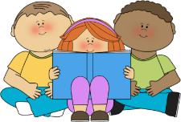



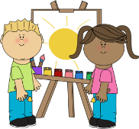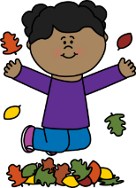

**Expressive Arts and Design**

**The children will be learning** …

* …to build and construct using our eco bricks.
* …to learn new songs.
* …to enjoy engaging with a range of tools and resources to create their own artwork.
* …to engage in pretend play imaginatively and purposefully in our ‘recycling centre’ role-play area.
* …to make models and musical instruments from used boxes and containers.
* ….to perform stories to an audience with confidence and expression.

**Understanding the World**

**The children will be learning …**

* … why the World is an amazing place.
* … the names of animals in our stories and find out where they live in the world using a world map.
* …the reasons why Christians believe that God is so important.
* …ways we can we take good care of our world.
* …to make a class charter of the things we will do to look after our world.
* …to sort, group and classify objects according to the material they are made of.
* …investigate the properties of water by freezing it and melting ice