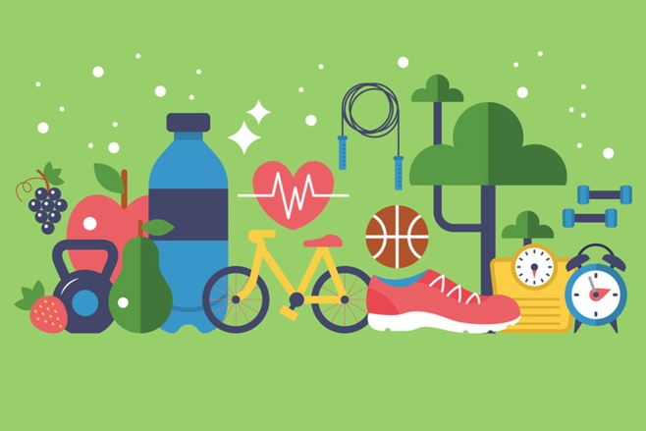
Wednesday 25th March 2020

Theme

Can you make a healthy habits poster?

Draw and label all the things we need to do to stay healthy.
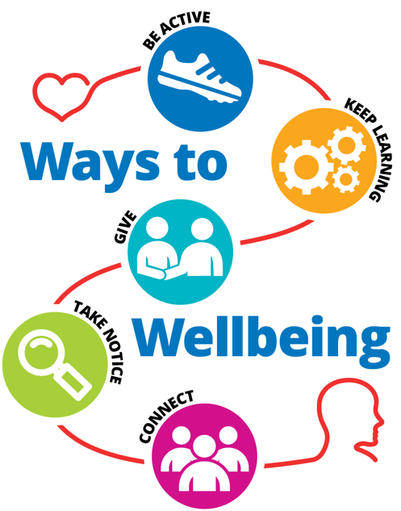
Think about your mind and body.

