**This term the children will be learning to…**

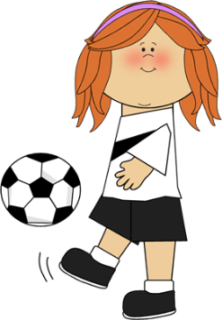

**Communication and Language**

…listen to stories with increasing attention and recall.

…join in with familiar nursery rhymes.

….respond to simple instructions.

…understand and answer ‘how’ and ‘why’ questions.

…use imaginative language while they are playing

…use words such as behind, next to, above, under, over etc.

**Personal, Social and Emotional Development**

…feel confident and happy in their new surroundings.

…develop their independence by selecting their own resources and activities and **tidying them away when they have finished.**

…form positive relationships with their peers and take turns and share the equipment.

…follow new routines and understand the expectations at school.

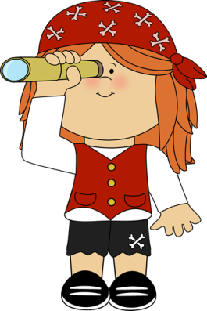

**Physical Development**

…travel confidently in a range of ways, adjusting speed and direction and learning a sense of their own space.

…use small tools such as pencils, pens, paint brushes and scissors with control.

… hold a pencil correctly to form the letters in their name.

…use equipment safely.





**Mathematics**

**...** recognise numbers that have a personal significance

…recite numbers in order up to10.

…recognise and read numbers up to 10.

…count 10 objects accurately.

…find one more than and one less than

…name and describe shapes in their play.

…use language such as shorter than, taller than, bigger than.

**Literacy**

….join in with nursery rhymes and say which words sound alike

…recognise letters in their names and know the sound

…hear and then say the sounds they hear at the beginning of simple words.

…begin to blend sounds together to read simple words.

… write their name by copying and then from memory







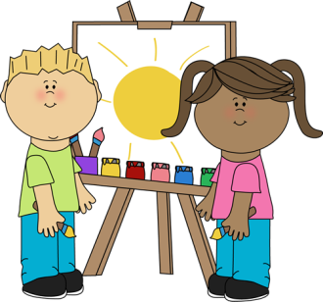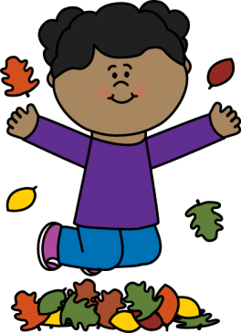

**Expressive Arts and Design**

…act out and develop stories as they are playing.

…sing new songs

…plan models using the construction kits.

…select and use the creative resources independently.

….explore different resources to draw a picture of themselves

**Understanding the World**

…talk about the world around us (at school and at home)

…talk about what they notice (for example seasonal changes in the outdoor environment)

…remember and talk about past events (such as birthdays and other celebrations)

…name different parts of their body

… use the computers to develop their learning.

