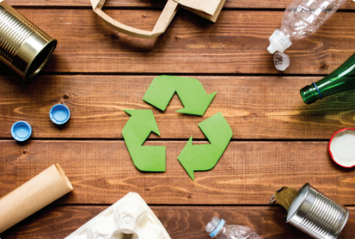

Using the ‘Six Rs’ to reduce waste

We can reduce waste using the ‘Six Rs’:

- Rethink – This is all about doing things differently to reduce waste. For example, taking reusable bags with us when we go shopping.
- Refuse – This is all about not using or buying something that will cause a lot of waste. For example, we might refuse to buy fast food because of the packaging it comes in.
- Reduce – This is all about using less of something. For example, we could use less cling-film when we put food in the fridge if we use containers with lids.
- Reuse – This is when we use something more than once. For example, glass milk bottles from the milkman are designed to be used and used again.
- Recycle -This is when we turn waste back into useful things. For example, waste glass, plastic, tins and paper we put in recycling bins can be turned into new packing and containers.
- Repair – This is when we mend things instead of throwing them away. For example, we would mend a car that breaks down rather than scrapping it and buying a new one.

Your task is to design a poster or presentation to encourage people to create less waste from packaging based on the ‘Six Rs’

