Miss McKeon’s Project 1 (Part 1)

 | 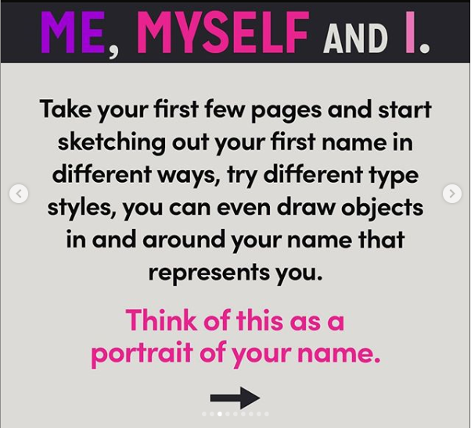 | 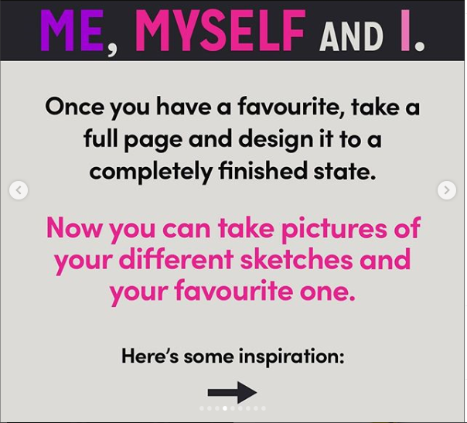 | 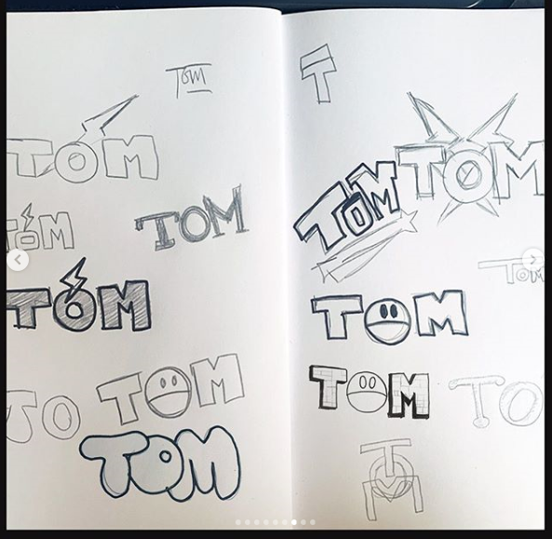
Have fun!
I’d love to see your work.
Send a photo to kmckeon@landscore-primary.devon.sch.uk

