Miss McKeon’s Project 2

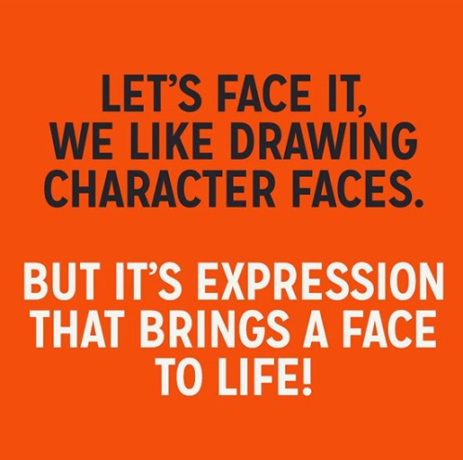 | 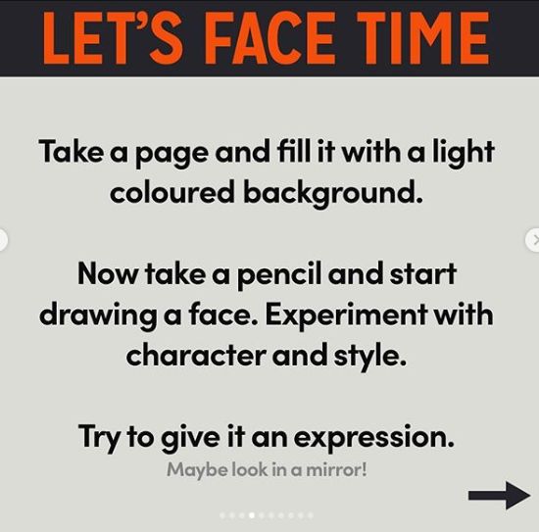 | 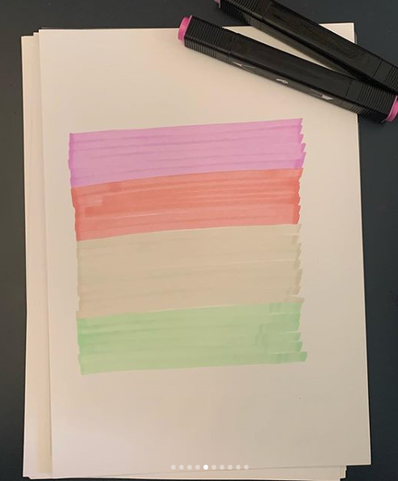 | 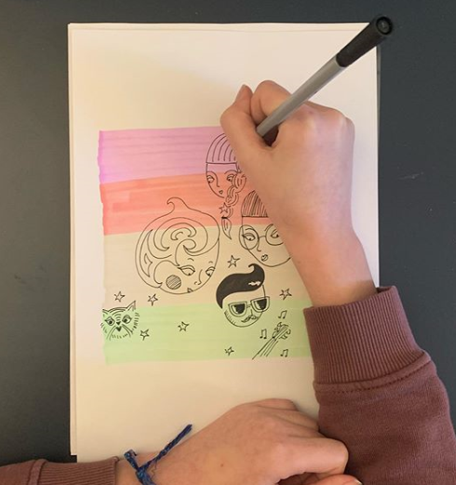
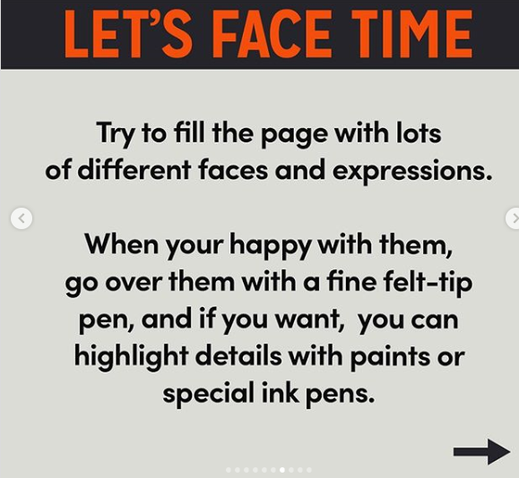 | 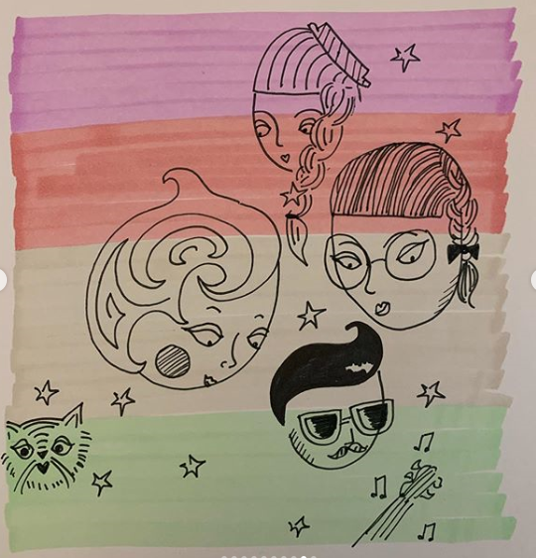 | Have fun!  I’d love to see your work.  Send a photo to kmckeon@landscore-primary.devon.sch.uk

