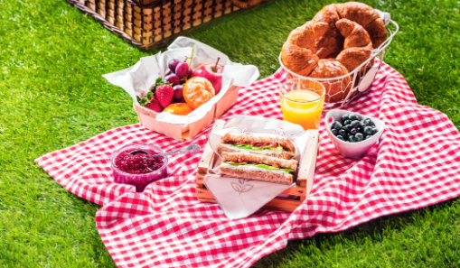

Planning a Healthy Picnic
(To have in your garden or inside!)

Your task is to plan how to pack a healthy picnic that:
- Avoids extra plastic food packaging
- Avoids disposable plastic forks/glasses
- Has healthy food and drinks

Key questions to think about:
- What are healthy picnic foods?
- What can we put it in to avoid more waste?
- How else can we avoid making waste?

Create a leaflet or invitation to give to the family members living with you to come along to your picnic. Make sure you include all of the information about why it is healthy and good for the environment.
If you can, take a picture and email it to us, we would love to see it!
Enjoy your picnic!

