Task: Marinella and Marino
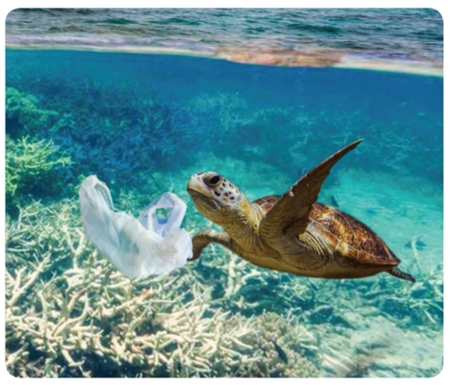

Marinella and Marino are marine turtles. They spend most of their life at sea. They like to eat sea-grass and jellyfish. Plastic bags in the sea like the one in the photo can look like a jellyfish. Some turtles try to eat plastic bags by mistake. The bags can harm the turtles… Your task is to write a story or a poem about Marinella and Marino, the marine turtles. Your story could be told by you or could be as if Marinella and Marino are telling their story.
Do some research about how plastic waste in the sea impacts on sea life to include in your writing – remember to only use reliable and safe websites!
Remember! A good story or poem has a beginning, a middle and an end.

