THEME: Farming

Your Challenge:
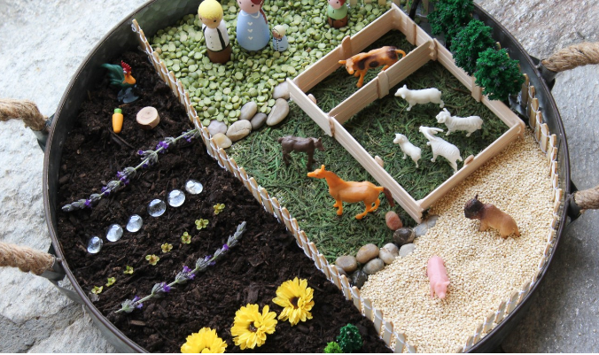
Can you create your own Small World Farm?
We would love for you to email in a photo of your creation and hopefully we will share them on our Team 3 video.
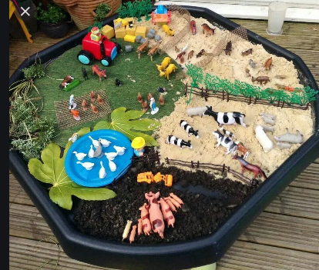

Success Criteria:
- A range of farming activities are shown.
- Labels explaining each part of the farm.
- Fun facts presented however you like.

