**Physical Development**

**The children will be learning to…**

* use either their right or left hand consistently.
* form letters correctly when writing.
* move easily around, under and through balancing and climbing equipment.
* hold and use scissors effectively.

**Communication and Language**

**The children will be learning to...**

* listen and respond to stories.
* make up their own stories in their play.

**Personal, Social and Emotional Development**

**The children will be learning to**

* talk about and celebrate differences.
* generate ideas of how to make people feel special and happy.
* explore feelings of being worried/anxious.

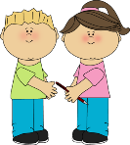

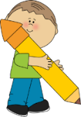

**Literacy**

**The children will be learning to...**

* link letters to their sounds and blend them to read simple words.
* read tricky words from memory.
* read simple books and captions.
* listen and respond to stories.
* write for purpose and meaning when making cards, invitations, recipes, letters and lists.
* draw and label family pictures.
* use phonic knowledge to make books.

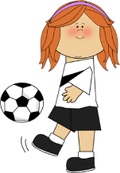

**Mathematics**

**The children will be learning to…**

* recognise, represent and compare numbers 1 to 5.
* find one more and one less with numbers up to 5.
* explore shape by noticing and describing their properties.
* understand and use words such as under, over, through, in and out.
* order events in their day and gain an understanding of ‘time’.



**Our theme this term is**

**“Let’s Celebrate!”**

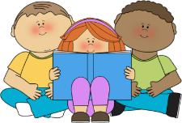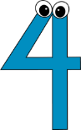



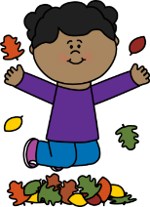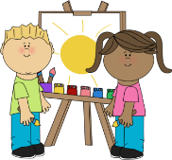

**Expressive Arts and Design**

**The children will be learning to…**

* design birthday cards.
* explore what happens when colours are mixed.
* create Firework pictures.
* enjoy playing party games.
* learn new songs.
* make Christmas cards and decorations.

**Understanding the World**

**The children will be learning to…**

* explore the different ways that people celebrate occasions such as Birthdays, Christmas and Bonfire night.
* talk about ‘family celebrations’.
* explore ice sculptures.
* observe and explore seasonal changes through outdoor learning.
* learn why Christmas is special to Christians.