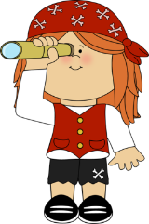**This term the children will be learning to…**

**Our learning will be linked to the story “Dear Zoo”**

**by Rod Campbell.** 

**Communication and Language**

* …follow a story without pictures or props.
* …listen and respond to ideas expressed by others in conversation or discussion.
* …extend their vocabulary and explore the meaning and sounds of new words

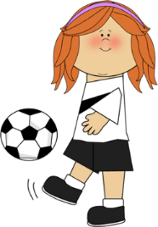

**Physical Development**

* …use a pencil and hold it effectively to form recognisable letters, most of which are correctly formed.
* … handle tools, objects, construction and malleable materials safely and with increasing control.
* …jump off an object and land safely.
* …travel with confidence and skill around, under, over and through balancing and climbing equipment.

**Personal, Social and Emotional Development**

* …explain what they know and what they understand and ask relevant questions of others.
* …talk about what they are good at and what they like about themselves.
* …understand that their own actions affect other people

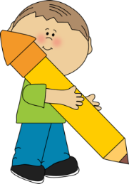

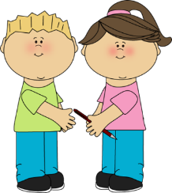



**Literacy**

* . ..learn the **names** of the letters of the alphabet.
* …read and understand simple sentences by talking about what they have read.
* …attempt to write short sentences in meaningful contexts.
* spell and write some irregular common words such as **the, to, was, have,** from memory.
* …ask questions and know that they can find the answers from books and computers.
* …understand the differences between non-fiction and fiction texts

**Mathematics**

* …count objects beyond 10.
* …count an irregular arrangement of objects up to 10.
* …estimate how many objects they can see and then check by counting them.
* …use the vocabulary involved in subtraction.
* …subtract two single digit numbers using objects and quantities.
* …order two items by weight and capacity.

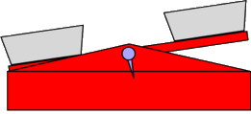

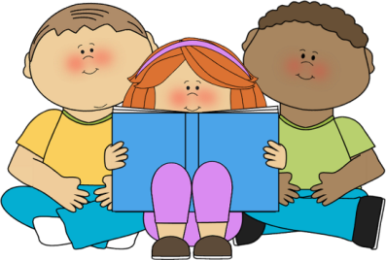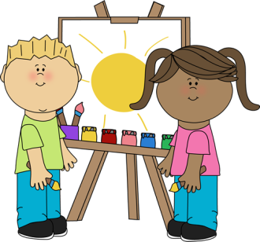

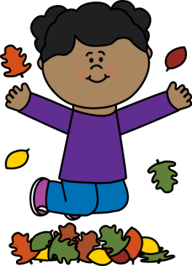

**Understanding the World**

* …know about similarities and differences between themselves and others
* …know about similarities and differences when exploring and learning about places, objects, materials and living things.
* …talk about the features of their own immediate environment and other different environments.
* …make observations of objects and plants and explain why some things occur and talk about change.
* …complete a simple program on a computer

**Expressive Arts and Design**

* …explain what happens when they mix colours.
* …experiment to create different textures.
* …understand that different media can be combined to create new effects.
* …engage in imaginative pretend play with others.

