**Foundation Stage Curriculum Information for Parents Summer Term 2018**

**Our topic this term is ‘First, next and then…’ with a link to life cycles.**

**We will start the Summer Term by reading the story of ‘The Very Hungry Caterpillar’ and learning about the life cycle of a caterpillar and other creatures. We will also be planting and growing seeds and finding out about the life cycle of a plant. We will also look at changes in our own lives.**

**The vocabulary of first, next and then will be used throughout our topic and the children will be encouraged to use these words when talking about their ideas and in their writing.**

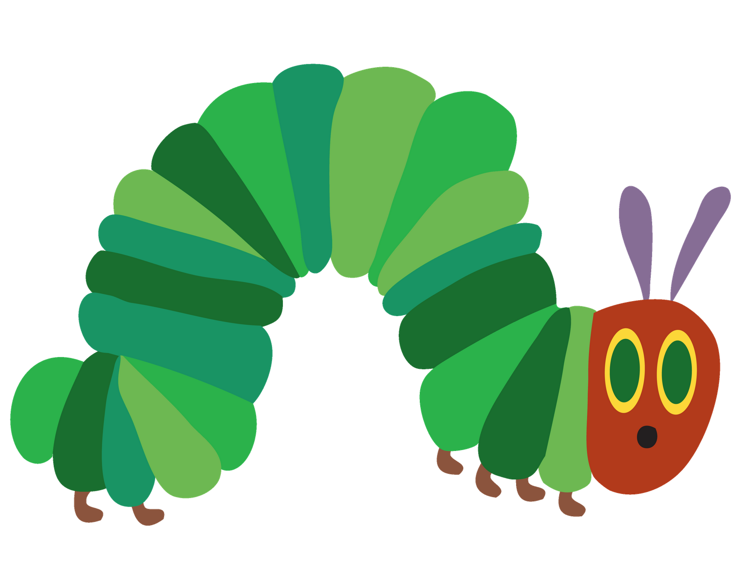

**This term the children will be learning to…**



**Communication and Language**

* …retell the story of “The very hungry Caterpillar” using expression and use their voices effectively, showing awareness of the listener.

...connect ideas and events using the words, first, next and then in order to develop narratives and explanations.

**Physical Development**

* …play team games and relay races
* …taste different fruits and vegetables to gain an understanding of the importance of a healthy diet.
* ….sort foods into groups of ‘things that are healthy for us to eat all the time and things that should be eaten sometimes’.
* ...handle equipment and tools and equipment safely and effectively when they are engaged in craft activities linked to our topic.

**Personal, Social and Emotional Development**

* …talk about their ideas and choose the resources they need for their chosen activity independently.

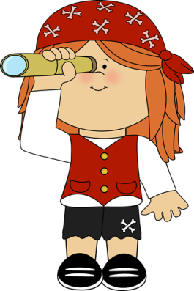



**Literacy**

* …invent their own stories using story language.
* ...write their own stories with a beginning, middle and an end.
* …write recounts of events (such as the life cycle of a caterpillar) using first, next and then.
* …record changes (for example the growth of a plant) in a simple diary format.
* …read and spell the days of the week.
* …write in simple sentences that can be read by themselves and others.
* …find out about plants and life cycles by looking at non fiction books.

**Mathematics**

* …order and sequence familiar events (such as the school day or morning routine).
* …use language to describe familiar periods of time and begin to recognise them on a clock. (for example I go to bed at 7 o’clock)
* …recognise coins and begin to understand their value.
* …solve calculations by doubling a number and understand that doubling is adding the same number together
* …solve problems involving halving by sharing objects or splitting a shape into two equal parts.
* …share a number equally using objects to support this.

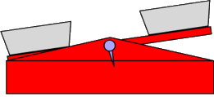



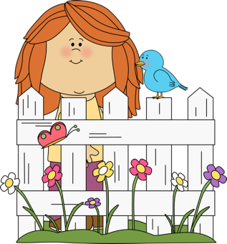

**Expressive Arts and Design**

* …make caterpillar and butterfly puppets from different materials.
* …act the story of ‘The very hungry caterpillar’.
* …learn new songs linked to our topic.
* …. make masks.
* …make cocoons from paper mache.
* …make caterpillar models.
* …represent the life cycle of a caterpillar through music and drama.

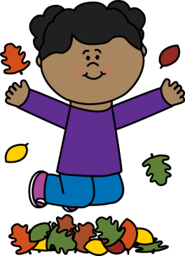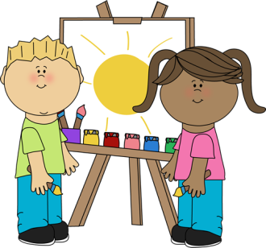

**Understanding the World**

* …make observations about animals and plants.
* ...talk about changes they notice in the world around them.
* …try and explain why some things occur.
* …plant seeds and learn about the conditions plants need to thrive.
* ..observe first-hand the life cycle of a caterpillar.
* …talk about changes that have happened in their own lives and think how they are different compared to when they were a baby.